SPOTIFY API







OMDb API

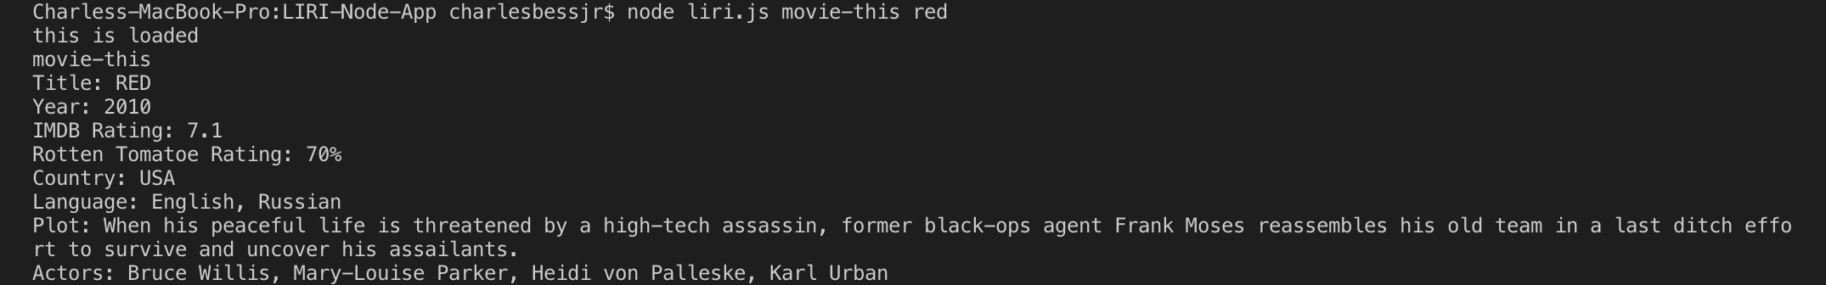

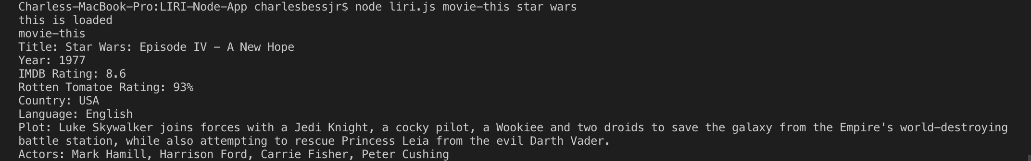

Bands In Town API

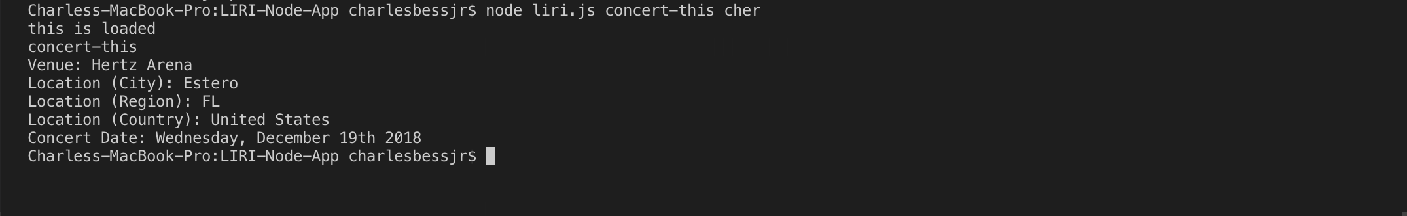

Do What It Says

